Game Guide:

—Alphabet Blast
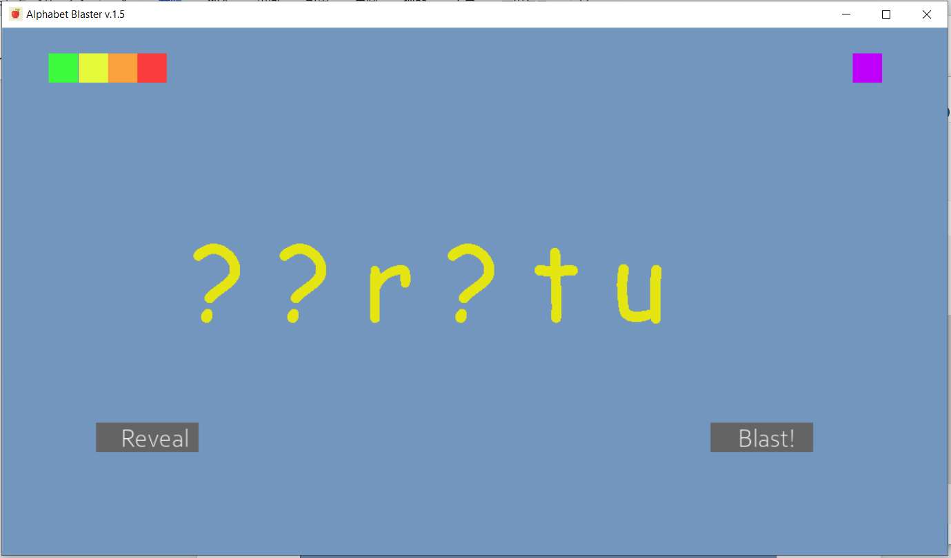
This game will randomly select six consecutive letters and hide 1, 2, 3, or 5 of them. To change how many letters are hidden, click one of the colored squares in the top left:

-Green: Hide one letter
-Yellow: Hide two letters
-Orange: Hide three letters
-Red: Hide four letters

To switch between upper- and lower-case letters, click the purple square. Clicking “Blast” will create a new random set of letters, and clicking “Reveal” will show which letters were hidden.

Note: When changing how many letters or which case is used, the yellow letters will not change until “Blast” is clicked.

—Alphabet Galaxy
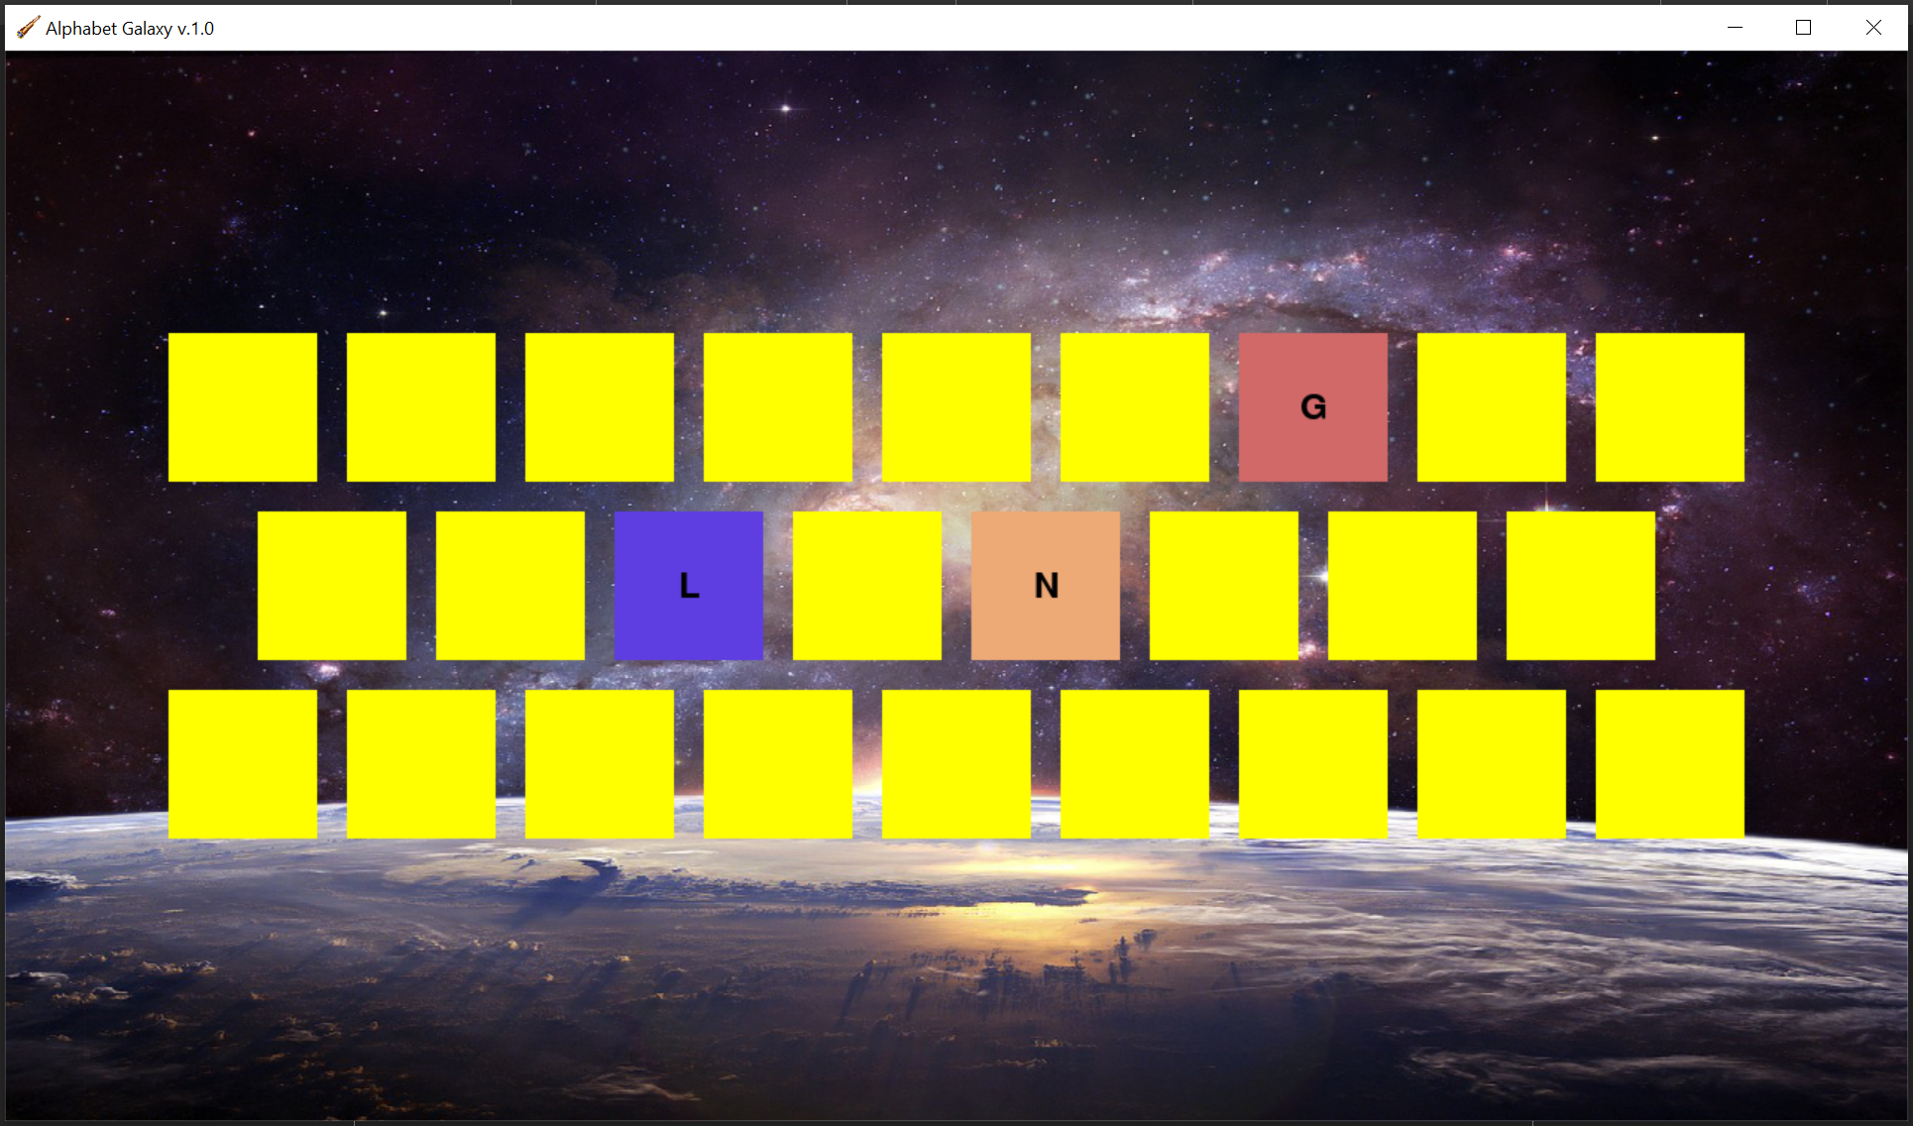
A simple alphabet review game. Click the squares to reveal the letters of the alphabet. Great if you have a suction cup ball for the children to throw. Can also have children review “what’s next?” and “what’s next to/above/below?” to review letter order and prepositions.
—Cowboy
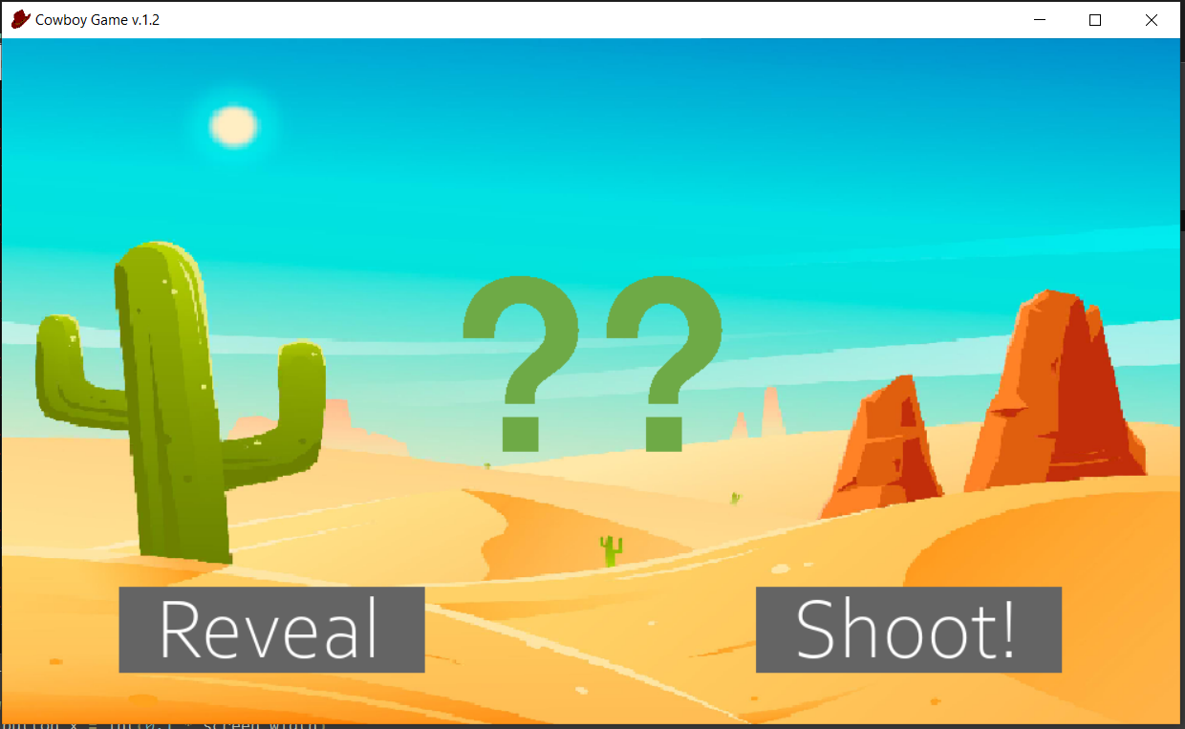
This game will randomly select options from the “cowboy” text file. To change the material being reviewed, simply edit the “cowboy” file in the “resources/cowboy” folder.

Put each option on a new line. For example, if you wanted to review counting by 10’s, your list would look like:
10
20
30
40
50
etc.

Clicking “shoot” will select a new option from the list, and “reveal” will show which option was selected.

—Find the Princess
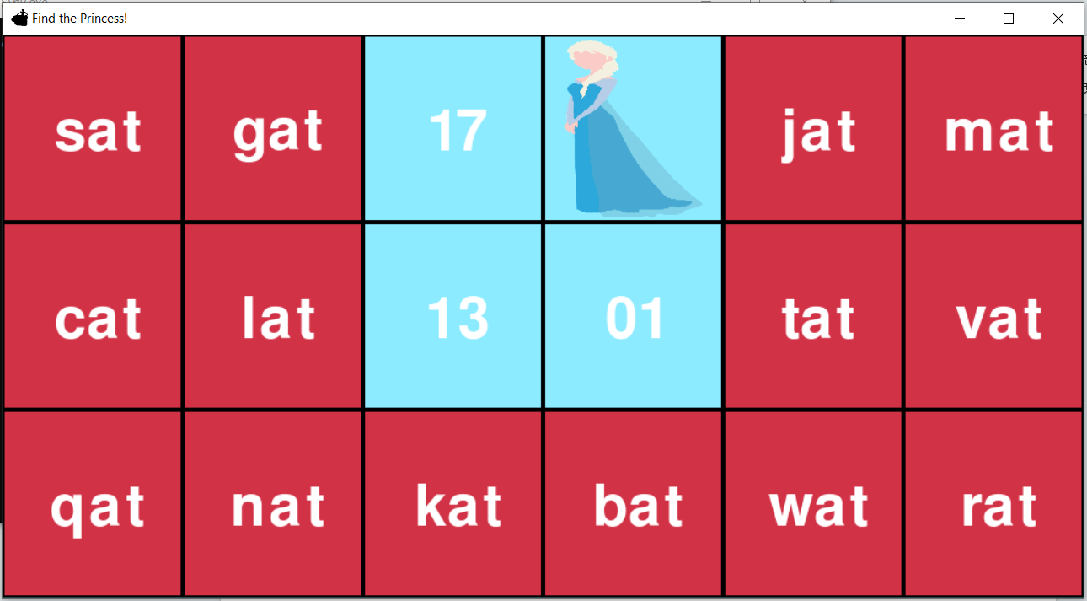
This game can be played two ways: either set the words on the rectangles and reward students with the points they reveal, or set the points on the rectangles and make the students read the words revealed.

To change what is placed on the rectangles, simply edit the list in the “rectangle_content” text file in the “resources/princess” folder. To change what is hidden under the rectangles, simply edit the list in the “hidden_content” text file in the “resources/princess” folder. You can also change the princess to Ultraman or a dinosaur by renaming the “princess.png” to “princess1.png” and then renaming the image you want to use to “princess.png”.

Warning—if you decide to change what’s hidden, be prepared to hear “I want (insert the latest fashionable favorite)!” It’s possible to add your own characters to the available character pool. Simply download a png with a transparent background, add it to the “resources/princess” folder, and name it “princessx.png”, where ‘x’ is a number you haven’t used before.

Note: Make sure to include 17 items in the “hidden_content” list and 18 items in the “rectangle_content” list, otherwise the program will break.

If you want to repeat values, simply put the same item on another line. For example, if you wanted a weighted points system (ie lower points are more common, higher points are less common), you could do a “hidden_content” list that looks like this:

5
5
5
5
10
10
10
10
25
25
25
50
50
50
75
75
100

—Letter Pop
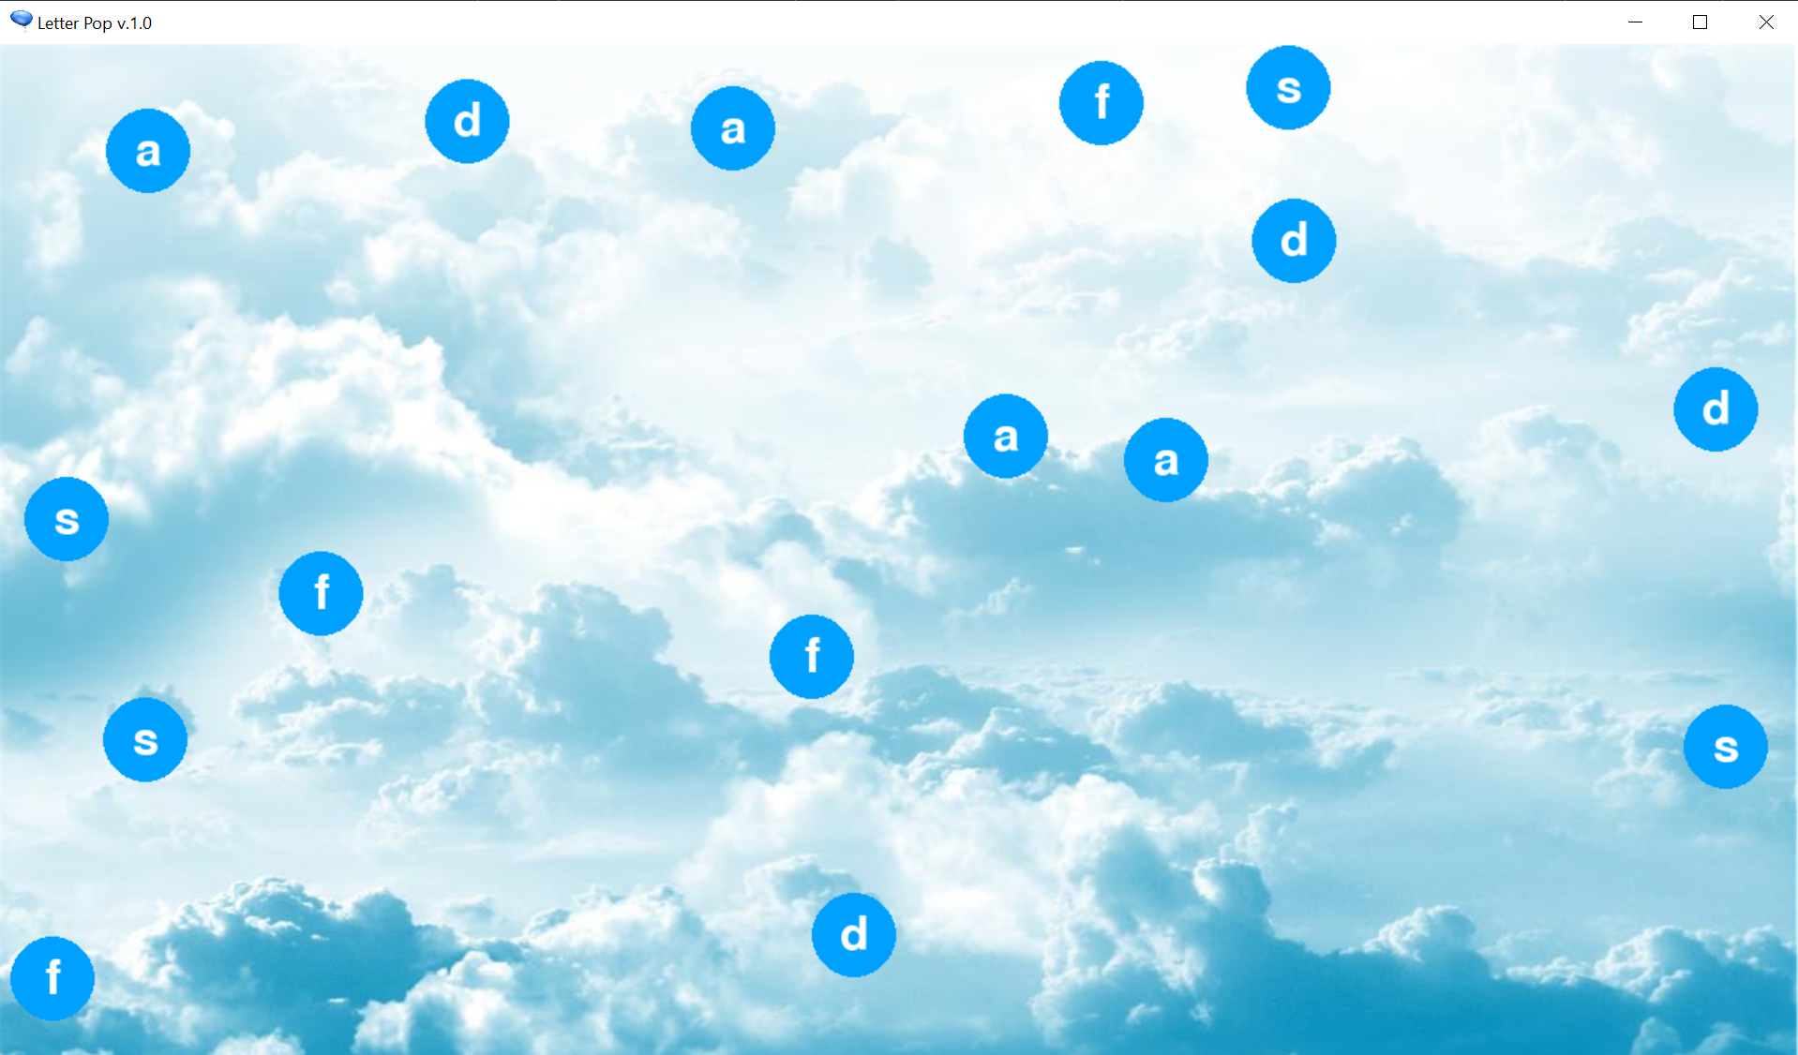This game populates “bubbles” for the children to pop. You can tell the children which letter to pop or let them say which letter they’re going to pop.

To change what is placed on the rectangles, simply edit the list in the “poppers” text file in the “resources/letter_pop” folder.

—Letter Reveal
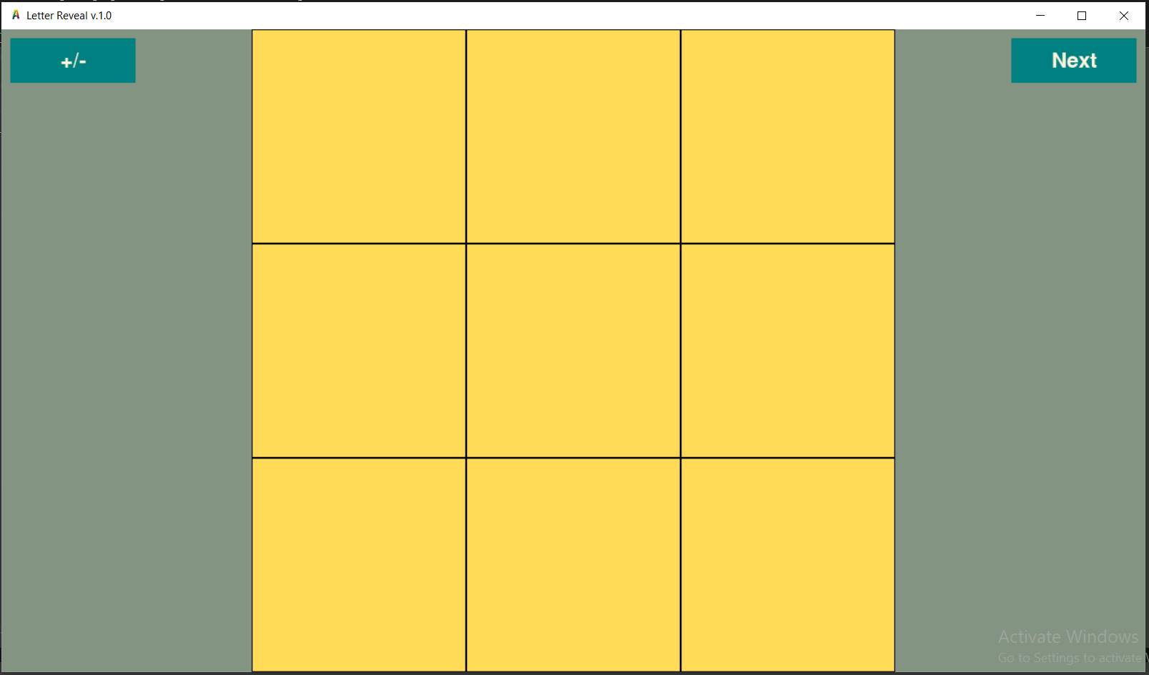
A simple letter review game. Click the squares to reveal the letter underneath. To change the letters being reviewed, simply edit the “letters” text file in “resources/reveal.” The game will go in the order you place the letters in the text file, ie, “b, g, d, a” will hide B first, then G, etc. To switch between upper and lower case letters, simply click the “+/-” button.

Note: There is a minor bug when manually adjusting the window size diagonally. Instead of a 3x3 square, it will create a slightly off-center 4x4 square instead. Sometimes the letter will also peak out from behind the squares. Most of the time this won’t happen, and it shouldn’t affect the game’s performance.

—Phonicsmon
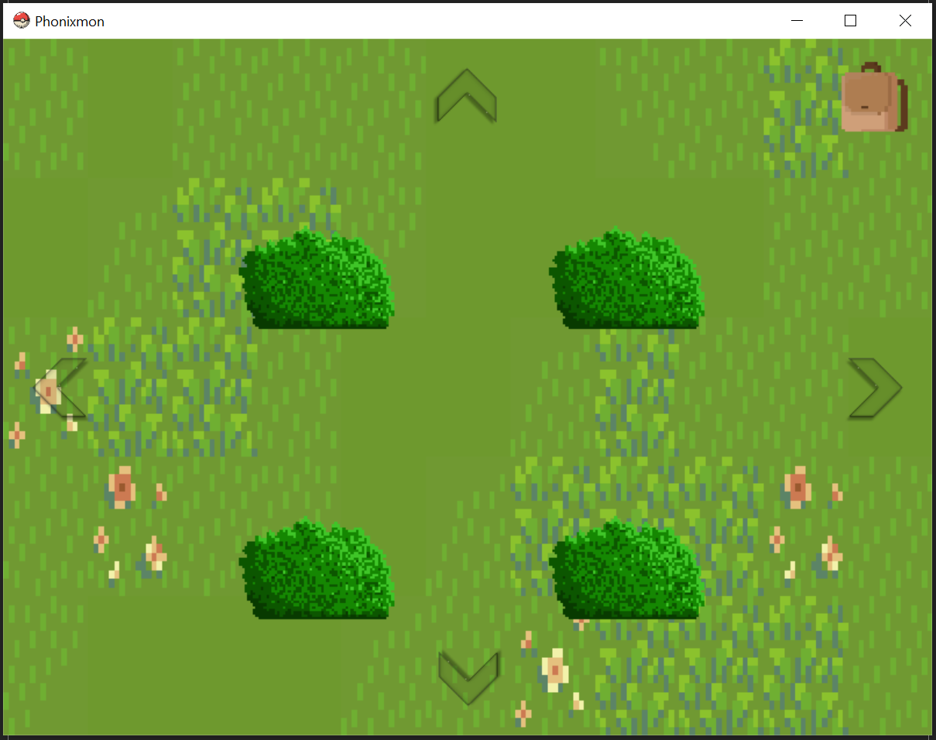
Probably the most complex of the programs. Does stuff. Lots of stuff. Crazy times, bro, crazy times.

—Random Wheel Spinner
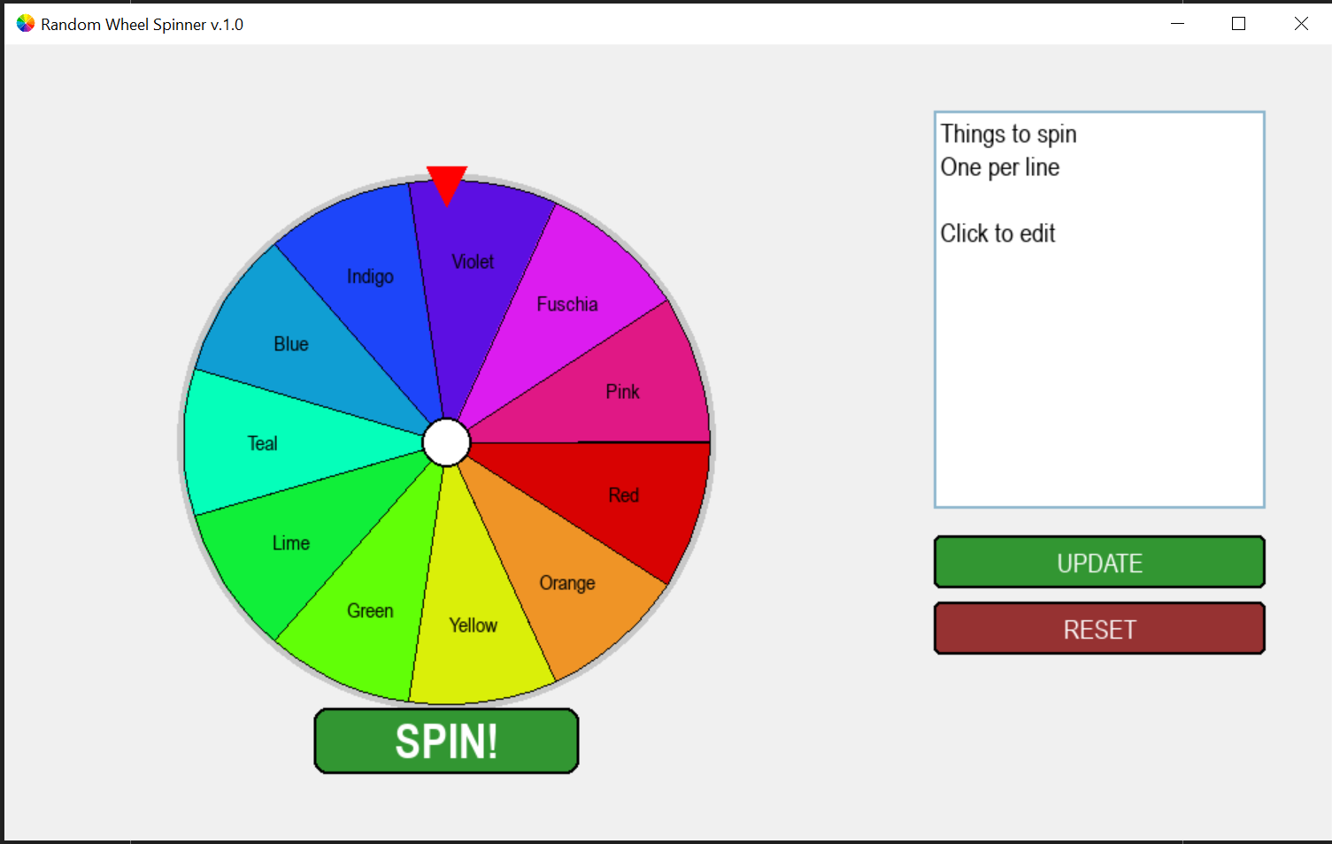
Does what it says on the tin. Backspace/delete keys sometimes don’t register, apologies. Cursor might blink in a weird spot after clicking reset. Great for all kinds of uses.

—Scuba Reader
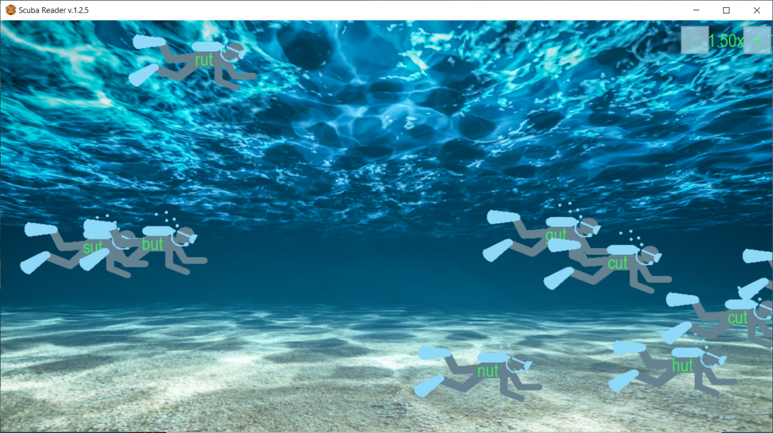
This game is great for vocabulary review and speed reading. It will automatically put all the words on the scuba divers and make them swim across the screen. To change which words are placed on the scuba divers, simply edit the list of words in the “scuba_words” text file in the “resources/scuba” folder. If you want to make the scuba divers scroll faster or slower, click the “+” to make them go faster and the “-” to make them go slower.

Put each option on a new line. For example, if you wanted to review the “-at” family, your list would look like:
bat
cat
fat
hat
sat
etc.

Note: Be careful not to do too many words at once, or the screen will become very crowded with all the scuba divers. You can put up to 10-12 words before the screen becomes too congested. Also, scuba divers will sometimes cover each other up or go below the bottom of the screen. (This is a known bug I haven’t been able to fix yet.)

—Star CVC
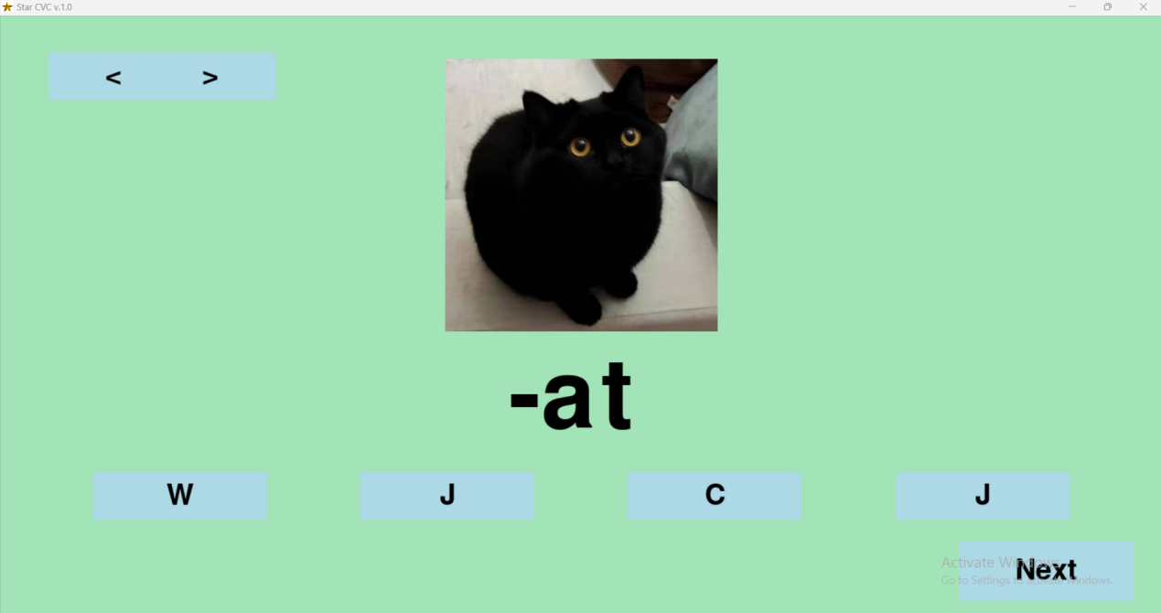
This game lets you review any CVC word family you wish. Students need to select the correct letter to complete the CVC. If they get it wrong, the letter will turn red. If they get it right, the letter will turn green, and the word will change under the image. You can navigate between the preloaded word families with the “<” and “>” in the top left. “Next” will go to a new random picture and word within the word family.

If you want to change the picture that a word uses, simply navigate to the correct word family folder in the “resources --> star --> families” file path. You can add a new word family by creating a new folder in this file path using the “-VC” naming template, then adding images with CVC labels inside your new folder. For example, if you wanted to add “big” and its related words, the word family folder should be named “-ig” and the images “big”, “dig”, “pig”, etc.
—Word Maker
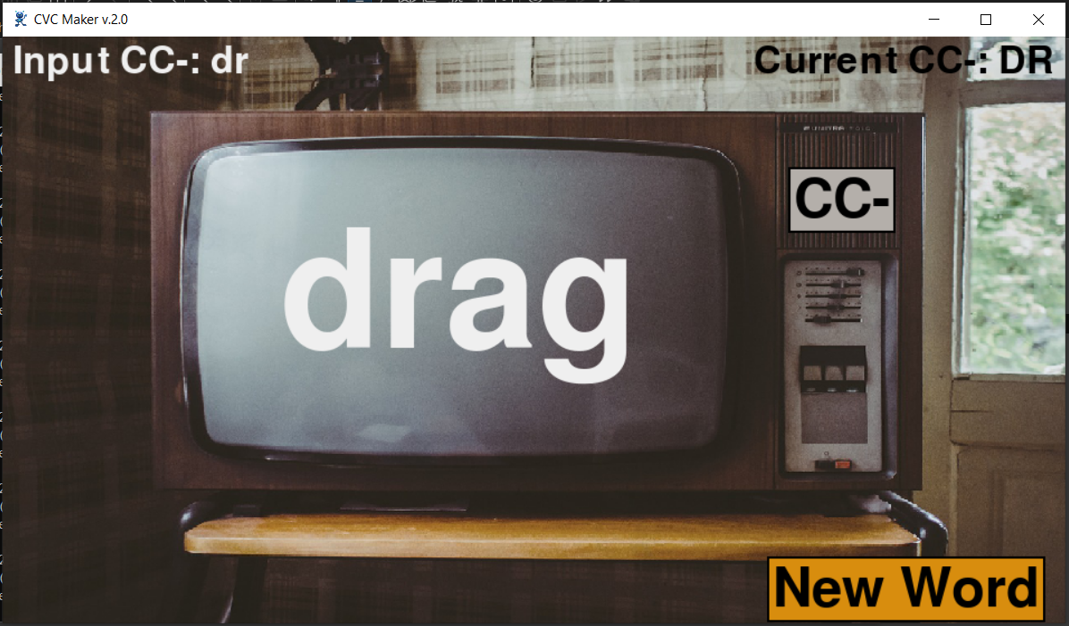
This game is great for reviewing word families (CVC words) and blends. To pick your word family, simply type the vowel and consonant combination anywhere on the screen and hit “Enter” to set it. Clicking the “New Word” button will put a random word on the television screen. To change word families, simply backspace away the previous entry, type your new word family, and then press “Enter” to set the new word family.

The Word Maker has several modes for different word generation. Each mode has different validation checks, so if it won’t create new words, check that you’ve set it to the correct mode.

-VC: Type a vowel and a consonant to generate simple CVC words. This mode only accepts VC inputs.
CC-: Type a consonant blend (CC) to generate CCVC words. If you type a blend and a vowel (ie “dra”), then the program will generate that word family (ie “drag, dram, drap,” etc.). If you only type a blend (ie “dr”), then the program will generate a variety of words (ie “drag, drum, drig,” etc.).
-CC: Type a consonant blend (CC) to generate CVCC words. If you type a vowel and a blend (ie “ing”), then the program will generate that word family (ie “bing, king, sing,” etc.). If you only type a blend (ie “ng”), then the program will generate a variety of words (ie “mung, xong, deng,” etc.).
TRI-: Type any three letter blend to generate a five-letter word (TRIVC). This mode only validates for three letters, since some trigraphs are composed solely of consonants, while others contain vowels.
-TRI: Type any three letter blend to generate a five-letter word (CVTRI). This mode only validates for three letters, since some trigraphs are composed solely of consonants, while others contain vowels.

Note: Please use the regular “Enter” key when setting your word family. If your keyboard has a number pad, its “Enter” key will not set the word family. You might see a weird box symbol at the end of your word family if you press that button instead of the normal keyboard “Enter” key.

